**Solution roadmap-**

## Current model architecture

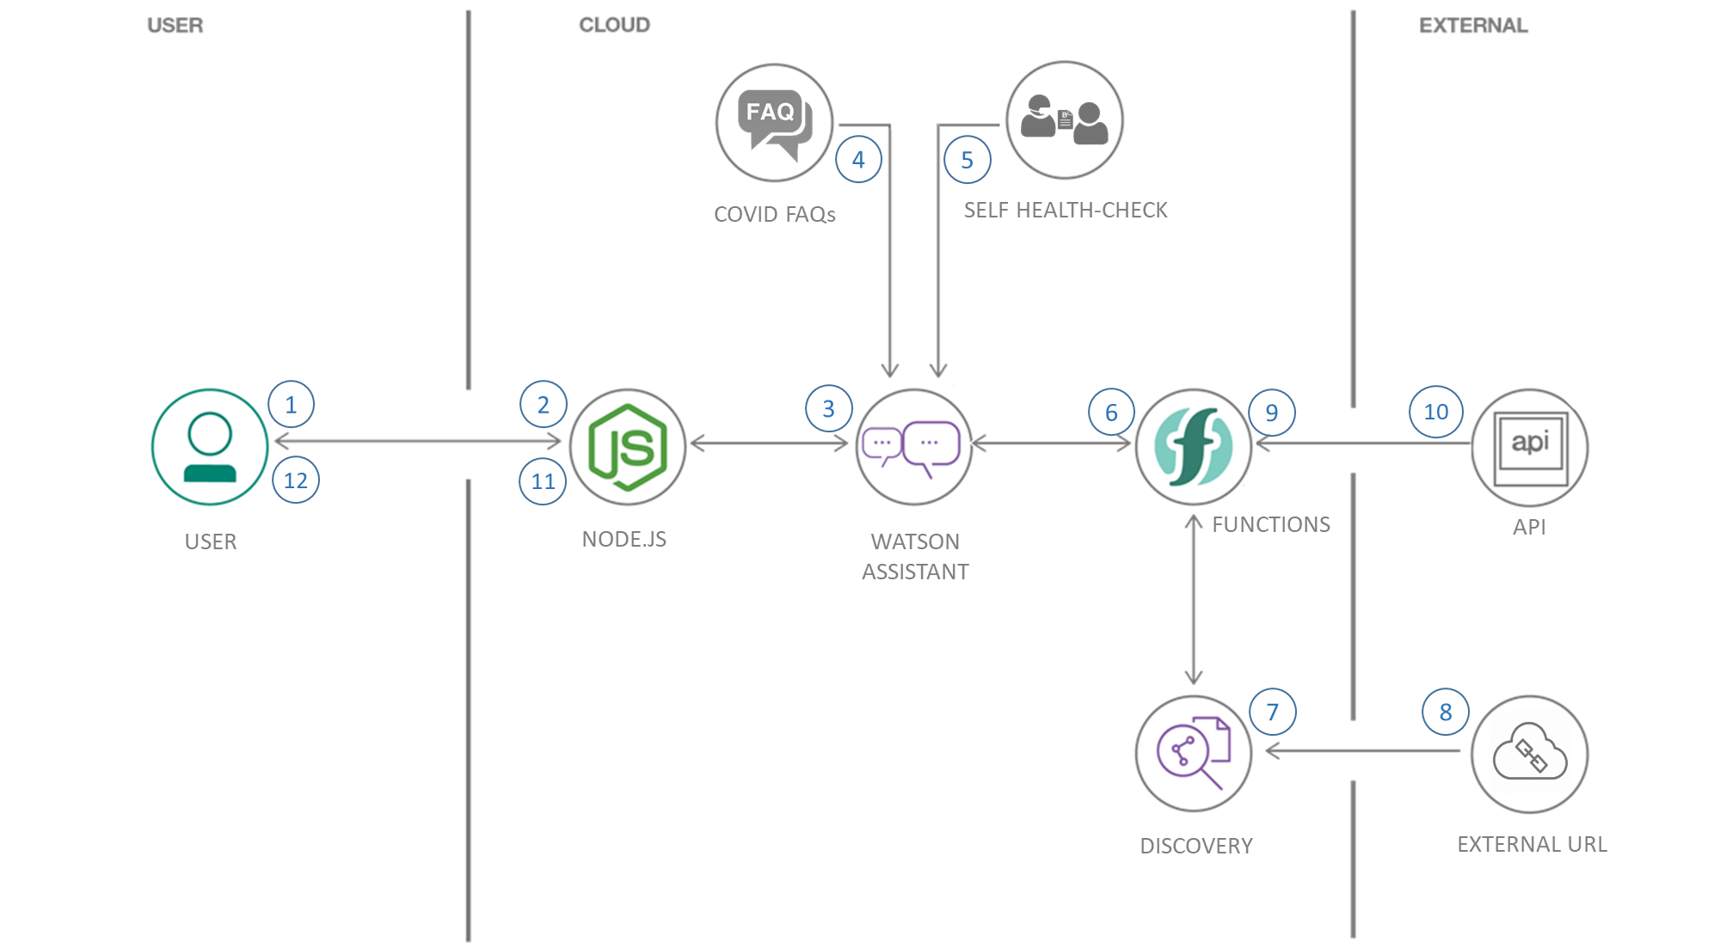

* The user visits a website with the COVID-19 chatbot and asks a question.
* The Node.js web server calls Watson Assistant hosted in IBM Cloud and passes on the question
* Watson Assistant uses natural language understanding and machine learning to extract entities and intents from the user question.
* Watson Assistant invokes an OpenWhisk open source-powered IBM Cloud Function.
* IBM Cloud Function calls Watson Discovery running in IBM Cloud which in turn presents an external URL for detailed information about current Covid-19 situation.
* IBM Cloud Function also calls a series of COVID-19 APIs to get Country wise / State wise / District wise near-real time statistics about the current pandemic situation (APIs included are - api.covid19api.com, api.covid19india.org, api.rootnet.in)
* The COVID-19 FAQ presents commonly asked questions about the pandemic for the user to select from.
* When Watson Assistant gets the input from the above steps, it replies to Node.js web server with the detailed information.
* There is another option for users to self-assess their current health status by answering a set of questions. Based on the inputs, Watson Assistant determines the probability of the users to get infected from Covid-19 and passes on the information to Node.js.
* The Node.js web server displays the information to the user.

## Future Scope

**Auto identification of User Location** - Currently user location is based on user’s input. Bot is detecting whether user’s zone is a containment area or not or providing list of nearest hospital based on input. Bot can be enhanced to detect user location automatically by using different google map API – like **Geocoding API**, **Directions API**, and **Distance Matrix API** etc. Code can be further enhanced to integrate these APIs with Watson assistance to get the user location real time and no need for user input.

* Funding required to integrate these APIs in the chatbot. Pricing details is available in the below location –

<https://cloud.google.com/maps-platform/pricing/?_ga=2.212909207.261577858.1596211234-120012358.1592819413>

**Speech to Text** - Bot is working in a text only mode. It can be upgraded to work in both speech and text mode integrating IBM Watson speech to text feature.​

**Mobile Application** - Bot is already integrated in Slack, which is accessible from mobile. However, buttons are not yet clickable in Slack, user has to provide input by typing in. This feature can be enabled in Slack by modifying the JSON file in-built in IBM Watson assistant.​

Other informative services like Ambulance Helpline, Police Helpline, Municipality / Govt. health dept. Helpline can be integrated further. We can add the feature to call these services directly from the Chatbot from both Web application and Mobile App.